**1.What is GIT?**

GIT is a distributed version control system and source code management (SCM) system with an emphasis to handle small and large projects with speed and efficiency.

**2.How to Install Git?**

To install git for windows you need to take this steps:

1)go to the <https://git-scm.com/> and press “download” button

2)download setup for your OS (Windows 7,8 x32 or x64 or Linux, Solaris, Mac OS X)

3)go through setup doing whatever setup demands

Installing on Linux

If you want to install the basic Git tools on Linux via a binary installer, you can generally do so through the basic package-management tool that comes with your distribution. If you’re on Fedora for example, you can use yum:

$ sudo yum install git-all

If you’re on a Debian-based distribution like Ubuntu, try apt-get:

$ sudo apt-get install git-all

For more options, there are instructions for installing on several different Unix flavors on the Git website, at <http://git-scm.com/download/linux>.

### [Installing on Mac](https://git-scm.com/book/en/v2/Getting-Started-Installing-Git#Installing-on-Mac)

There are several ways to install Git on a Mac. The easiest is probably to install the Xcode Command Line Tools. On Mavericks (10.9) or above you can do this simply by trying to run git from the Terminal the very first time. If you don’t have it installed already, it will prompt you to install it.

If you want a more up to date version, you can also install it via a binary installer. An OSX Git installer is maintained and available for download at the Git website, at <http://git-scm.com/download/mac>.

Figure 1-7. Git OS X Installer.

You can also install it as part of the GitHub for Mac install. Their GUI Git tool has an option to install command line tools as well. You can download that tool from the GitHub for Mac website, at[http://mac.github.com](http://mac.github.com/).

**3.What is a repository in GIT?**

A repository contains a directory named .git, where git keeps all of its metadata for the repository. The content of the .git directory are private to git.

**4.What are the advantages of using GIT?**

a)      Data redundancy and replication

b)      High availability

c)       Only one.git directory per repository

d)      Superior disk utilization and network performance

e)      Collaboration friendly

f)       Any sort of projects can use GIT

**5.What language is used in GIT?**

GIT is written on ‘C’ language makes this possible by reducing the overhead of runtimes associated with higher languages.

**6.What is “Staging Area” or “Index” in GIT?**

Before completing the commits, it can be formatted and reviewed in an intermediate area known as ‘Staging Area’ or ‘Index’. Situation just before commit.

**7.How to check settings?**

If you want to check your settings, you can use the git config --list command to list all the settings Git can find at that point.

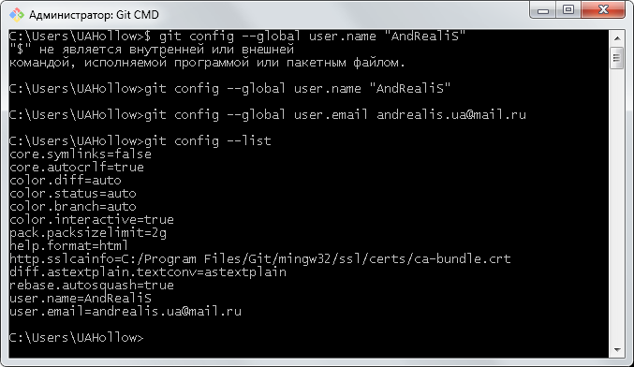

You can also check what Git thinks a specific key’s value is by typing git config <key>

8.How to get help?

If you ever need help while using Git, there are three ways to get the manual page (manpage) help for any of the Git commands:

**$** git help &lt;verb&gt;

**$** git &lt;verb&gt; --help

**$** man git-&lt;verb&gt;

For example, you can get the manpage help for the config command by running

**$** git help config

**9.How can you create a repository in Git?**

In Git, to create a repository, create a directory for the project if it does not exist, and then run command “git init”. By running this command .git directory will be created in the project directory, the directory does not need to be empty.

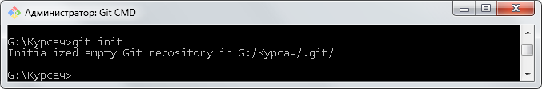

**10.how to start tracking a project which already exists?**

If you’re starting to track an existing project in Git, you need to go to the project’s directory and type:

**$** git init

This creates a new subdirectory named .git that contains all of your necessary repository files – a Git repository skeleton.

If you want to start version-controlling existing files (as opposed to an empty directory), you should probably begin tracking those files and do an initial commit. You can accomplish that with a few git add commands that specify the files you want to track, followed by a git commit:

**11.** **How git add works?**

Input “git add .” to add all files from current directory.

**12.** **how to commit changes?**

Use git commit –m “message” command to commit changes to repository.

**13. what is commit message?**

Commit message is a feature of git which appears when you commit a change. Git provides you a text editor where you can enter the modifications made in commits.

**14.How can you bring a new feature in the main branch?**

To bring a new feature in the main branch, you can use a command “git merge” or “git pull command”.

**15. how to merge to branches?**

Git merge <branch name> command will merge current branch with named.

**16.how to see commit list?**

Use “Git log” command.

**17.how to get changes from repository into current branch?**

Use “git pull” command.

**18.how to get changes from server without work directory update?**

Use “git fetch” command.

**19.What is the function of ‘git reset’?**

The function of ‘Git Reset’ is to reset your index as well as the working directory to the state of your last commit.  
**20. What is GIT stash?**

GIT stash takes the current state of the working directory and index and puts in on the stack for later and gives you back a clean working directory.  So in case if you are in the middle of something and need to jump over to the other job, and at the same time you don’t want to lose your current edits then you can use GIT stash.

**21. What is GIT stash drop?**

When you are done with the stashed item or want to remove it from the list, run the git ‘stash drop’ command.  It will remove the last added stash item by default, and it can also remove a specific item if you include as an argument.

**22.What is the function of ‘git stash apply’?**

When you want to continue working where you have left your work, ‘git stash apply’ command is used to bring back the saved changes onto the working directory.

**23. How will you know in GIT if a branch has been already merged into master?**

Git branch—merged lists the branches that have been merged into the current branch

Git branch—-no merged lists the branches that have not been merged

**24.What is the function of git clone?**

The git clone command creates a copy of an existing Git repository.  To get the copy of a central repository, ‘cloning’  is the most common way used by programmers.

**25.What is the function of ‘git config’?**

The ‘git config’ command is a convenient way to set configuration options for your Git installation.  Behaviour of a repository, user info, preferences etc. can be defined through this command.

**26. What does commit object contain?**

a)      A set of files, representing the state of a project at a given point of time

b)      Reference to parent commit objects

c)       An SHA1 name, a 40 character string that uniquely identifies the commit object.

**27.What is ‘head’ in git?**

It’s the reference for the current commit.

**28.What is the purpose of branching in GIT?**

The purpose of branching in GIT is that you can create your own branch and jump between those branches. It will allow you to go to your previous work keeping your recent work intact.

**29.What is the common branching pattern in GIT?**

The common way of creating branch in GIT is to maintain one as “Main“

branch and create another branch to implement new features. This pattern is particularly useful when there are multiple developers working on a single project.

**30.What is a ‘conflict’ in git?**

A ‘conflict’ arises when the commit that has to be merged has some change in one place, and the current commit also has a change at the same place. Git will not be able to predict which change should take precedence.

**31.How can conflict in git resolved?**

To resolve the conflict in git, edit the files to fix the conflicting changes and then add the resolved files by running “git add” after that to commit the repaired merge,  run “git commit”.  Git remembers that you are in the middle of a merger, so it sets the parents of the commit correctly.

**32.To delete a branch what is the command that is used?**

Once your development branch is merged into the main branch, you don’t need

development branch.  To delete a branch use, the command “git branch –d [head]”.

**33.What is the difference between ‘git remote’ and ‘git clone’?**

‘git remote add’  just creates an entry in your git config that specifies a name for a particular URL.  While, ‘git clone’ creates a new git repository by copying and existing one located at the URI.

**34. What is the function of ‘git diff ’ in git?**

‘git diff ’ shows the changes between commits, commit and working tree etc.

**35.What is ‘git status’ is used for?**

As ‘Git Status’ shows you the difference between the working directory and the index, it is helpful in understanding a git more comprehensively.

**36.What is the function of ‘git checkout’ in git?**

A ‘git checkout’ command is used to update directories or specific files in your working tree with those from another branch without merging it in the whole branch.

**37.What is the function of ‘git rm’?**

To remove the file from the staging area and also off your disk ‘git rm’ is used.